GLOSSARY OF E.T.'s ABBREVIATIONS

A.P. Kit – Army Pack
A.S.C – Army Service Corps
B.E.F – British Expeditionary Force
B.T. – Bayonet Training
C.B - Counter-Battery
f/C Post – Fire Command Post
F.O.P. – Forward Observation Post
H.A. – Heavy Artillery
H.A.G – Heavy Artillery Group
M.B. – Medical Board
M.G.C. – Machine Gun Corps
O.C. – Officer Commanding. E.T writes: O/C
O.P. – Observation Post
Q.W.R. – Queen's Westminster Rifles
R.F.A – Royal Field Artillery
R.F.C. – Royal Flying Corps
x/c – Exercise Controller

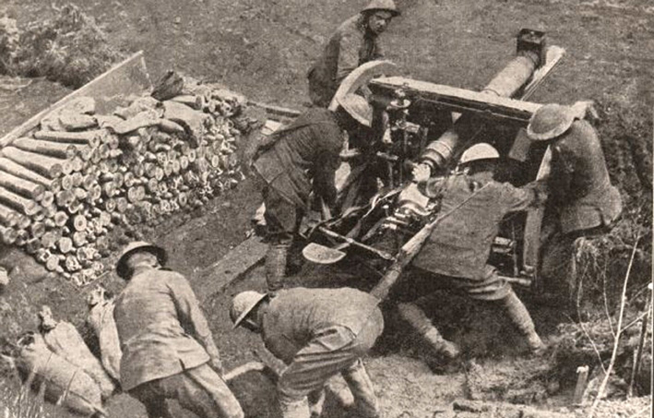
Positioning 16-pounder – Battle of Arras 1917

