JANUARY 1917

1^{st.} Shooting with 15 pounders and then 6" howitzers. All week at Lydd, I being x/c or observer daily, with map work for next day at night. Thorburn away. Beautiful clear bright weather always, but sometimes cold.

5^{th.} Left Lydd on mobilisation leave. Night at Rusham Road with Father and Mother.

6^{th.} Julian to breakfast. With Mother to stores. Lunch with Eleanor and tea with Joan and Bertie. Home with Bronwen( returning from Chiswick). All well.

7^{th.} Walks with Helen and children. Fine day.

8^{th.} Eleanor came and stayed the night. Wrote cheques for next 6 months.

9^{th.} Eleanor left. Helen and I walked in forest.

10^{th.} Dentist's. Lunch with Jones and Harry. Tea with Ivy Ransome and then Ingpen and Davies. Saw V.H. Collins. Home.

11^{th.} Said goodbye to Helen, Mervyn and Baba. Bronwen to Rusham Road. Lunched with Mrs. Freeman: afterwards saw Haynes and McCabe. Tea with Jesse and T. Clayton and Lipchitz. Supper at Rusham Road with all my brothers.

12^{th.} A letter from Helen. Goodbye to Bronwen, Mother and Father. Lunch with Mary and Margaret. Saw Irene. To Lydd and found only Horton and Grier; Thorburn gone on to Codford. Letters from Helen and Blanco White; to Helen, Mother, Mrs. de la Mare, Frost, Ellis, Hudson, Eleanor and John Freeman.

13^{th.} Nothing to do but test compass which never gives same results. Walk and tea with Flawn. Cold drizzle. Horton and the battery left early for Codford. Even wrote verse. Early to bed.

This is the verse referred to:

The sorrow of true love is a great sorrow
And true love parting blackens a bright tomorrow.
Yet almost they equal joys, since their despair
Is but hope blinded by its tears, and clear
Above the storm the heavens wait to be seen.
But greater sorrow from less love has been
That can mistake lack of despair for hope
And knows not tempest and the perfect scope
Of summer, but a frozen drizzle perpetual
Of drops that from remorse and pity fall
And cannot ever shine in the sun or thaw,
Removed eternally from the sun's law.

14^{th.} A Sunday and no letters as I am supposed to be at Codford. Letters to Helen and Blanco White. A bright day. Walked with Flawn through Old Romney and Dymchurch. Flawn to tea with me. Packing.

15^{th.} Up 6. Packing. Left Lydd at 9 with R.M.S and Grier and 3 men. Light snow and red sun. 4 hours to spare in London but could only see T. Clayton and D. Williams: could not find J. Freeman. Then to Codford in the dark, writing to Helen and beginning 'A Sentimental Journey'. Arrived too late for dinner.

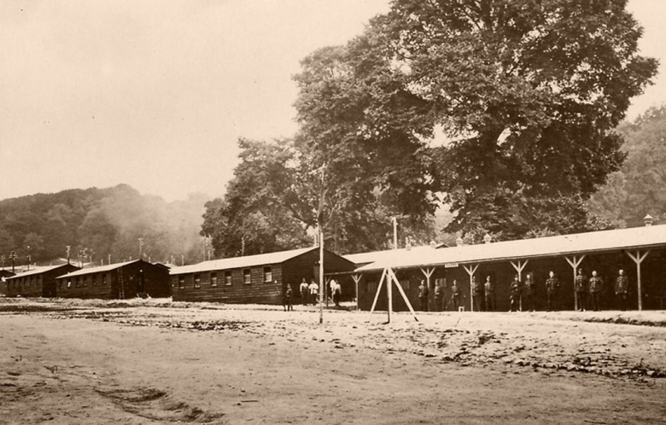
Codford camp

16^{th.} Letters from Helen, Eleanor, Mervyn, Garnett, Haines, Mrs. Ellis. Took route march to Wigtye, Stockton, Sherrington and had great luck in short cuts and bye-roads over river. A frosty clear day: men singing 'Dixie', 'There's a long long trail of winding to the land of my dreams', and 'We're here because we're here' to the tune of Auld Lang Syne. Only Smith and I and Capt. Fenner left of the 6 officers. Afternoon walked with Smith to Chitterne and had tea there. Evening dined together and talked about practical education – pronunciation of 'girl', 'soot' and 'historian' – and about rhymes to eye.

17^{th.} Light snow in night; hard frost. Men on fatigues or drawing overseas clothes etc. Office full of boots, blankets, pails, axes, shovels, dixies, stretchers etc. Route march to Tytherington, Heytesbury and Knook. Afternoon walked over downs by Stockton Wood to Chilmark with Smith. Tea at the inn and Smith played ragtime etc. A cloudy clear frosty day. Back over the Downs on a dark night, but only went astray 200 yards. Letter from Helen, Mother and John Freeman. Letters to Helen, Mother, Haines , Eleanor.

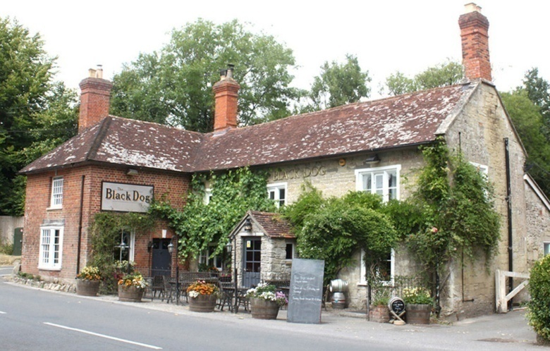
The inn at Chilmark - 2022

18^{th.} Letters from Helen, Hodson, Mrs. de la Mare, Father. Letters to Helen, Irene, Father. To Warminster to the bank. Still frosty. Afternoon lectured on map-reading. Orderly officer for camp from 6 p.m. Indoors all evening, talking to Smith about marching songs etc.

19^{th.} Letters from Mother, Helen, Miss Coltman, Hudson. Letters to Mother, Helen, M.Freeman, Lady Newbolt, Oscar. Morning orderly officer – latrines etc, - lectured on maps – paid Battery. Afternoon learnt to ride motor cycle. Mild and drizzly. Guns are due to arrive. A cake from Mother. Shakespeare's Sonnets from Helen. Capt. Fenner talks of having to take sick leave.

20^{th.} Letter from J.Freeman. Letters to Garnett, Guthrie, Harry, Miss Coltman. Mild snowy. Arranging stores. Guns arriving. Smith to Bath. So I had to see to unloading and parking the guns until dark. No use walking after dark. The roads are pitch dark and crowded with men going to cinemas, darkness worse from blaze of motor lamps and electric light in camps nearby. Long queues waiting outside cinema at 5.30. Tested battery compass. Talk with Fenner about martens in Ireland, badgers, plovers, barrows etc.

21^{st.} No church parade for me. 9.30 – 1.30 walked over Stockton Down, the Bake and under Grovely Wood to Barford St. Martin, Burcombe, and to lunch at Netherhampton House with Newbolts. Freezing drizzle – freezes on ground, white grass and icy roads. 2 families of vagrants in green road roasting a corpse of something by slow wood fire. Beautiful Downs, with one or two isolated thatched barns, ivied ash trees, and derelict threshing machine. Old milestones lichened as with battered gold and silver nails. Back by train at 5. Tea alone. Guns in line out on parade square. Smith back. Letter from Helen, Ingpen, Eleanor, Hudson. Letter to Helen, Ingpen. Talk with Fenner after dinner about fishing – river and sea.

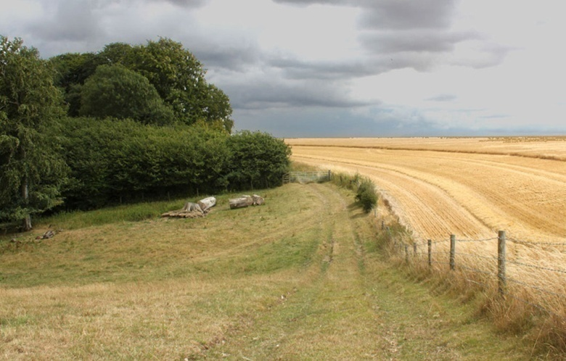
The track to the Bake - 2020

22^{nd.} Set the men branding and sorting stores. Left at 10.30 for Gloster to see Haines. Still frosty and dull. Gloster at 2.50. Sat till 12.15 gossiping about Frost, de la Mare and the army, marching songs etc. Haines gave me Frost's 'Mountain Interval'.

23^{rd.} With Mrs. Haines and Robin most of morning. 3.30 left Gloster via Mangotsfield and Bath for Codford. Read 'Mountain Interval'. Horton, Rubin and Thorburn back. Fenner merry; he is probably to go on sick leave. He and Rubin returned late and had a noisy parting from 2 others. Thorburn had a screaming nightmare.

24^{th.} All men on fatigues. A short walk with Thorburn to test compasses. Letter from Helen, Father, Mother, Harry. Letters to Helen, Father, Mother, M. Freeman. Parcel of medicines etc. from Helen. Cigars from Harry. Walked in afternoon with Thorburn to Chilmark for tea, and back over frosty Downs with new moon and all stars. But my ankles chafed by new boots lame me.

25^{th.} Resting my sore ankles. Dial sights tested and stores arranged for packing tomorrow. Guns leave on 27th and Battery on 29th. Fenner is to go to hospital and Horton to take charge. Very cold with East wind. Letters from Oscar, letters to Oscar, Helen, Mother, Mrs. de la Mare, Frost, John Freeman, Mrs. M. Freeman, Harry, Eleanor. Capt. Lushington to be our new O/C and to take us out.

26^{th.} Letters from Helen, Eleanor, letters to Helen, Mervyn. Loading lorries and attaching guns to 4-wheel drives – standing out in dusty and icy East wind doing nothing but getting cold and dirty. I sleep badly too. Also I have taken charge of mess and mess accounts. Thorburn is on my nerves – he had a nightmare lately – asking 'Can you tell me how much 55 lbs. is?' – the weight of officers' luggage. I feel useless. Am still in slacks and shoes on account of bad ankles. Thorburn and I dining alone, the others with Capt. Lushington in the village – our mess kit being packed. Can't even walk far enough to get warm. Thorburn goes tomorrow with guns. Dined with him and then talked about philosophy and poetry, and Yes and Perhaps, and the lyric and the Bible. I have a cold. The frost is worse tonight.

27^{th.} A clear windy frosty dawn, the sun like a bright coin between the knuckles of opposite hills seen from sidelong. A fox. A little office work. Telegram to say Baba was at the Ransome's, so I walked over Downs by Chicklade Bottom and the Fonthills to Hatch, and blistered both feet badly. House full of ice and big fires. Sat up wth Ivy till 12 and slept till 8. A fine bright frosty day.

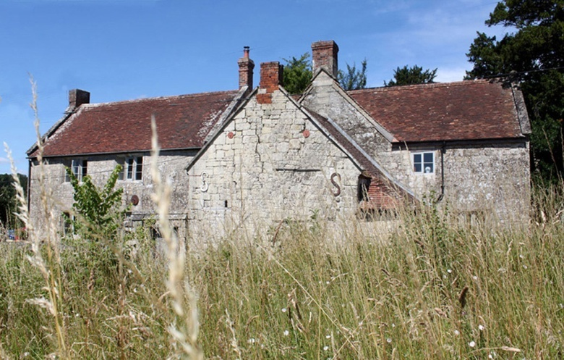
Hatch Farmhouse - 2022

28^{th.} Wrote to Bronwen, Helen, Ivy, Eleanor. Letters from Bronwen, Helen, Mother, Eleanor. Slept late. Rested my feet, talking to the children or Ivy cooking with Kitty Gurd. Hired a bicycle to save walking. Such a beautiful ride after joining the Mere and Amesbury Road at Fonthill Bishop – hedge-less roads over long sloping Downs with woods and sprinkled thorns, carved with old tracks which junipers line – an owl and many rabbits – a clear pale sky but a faint sunset – a long twilight lasting till 6. We are to move at 6.30 a.m. tomorrow, Horton and Smith and I dined together laughing at imbecile jests and at Smith's own laughing. Had to change in order to send home my soiled things. Letters. Mess accounts and cheques to tradesmen.

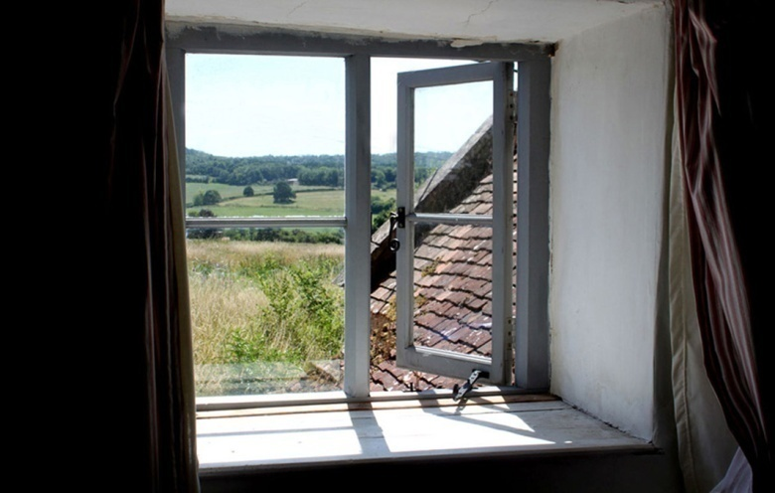E.T.'s bedroom window, Hatch Farmhouse - 2022

29^{th.} Up at 5. Very cold. Off at 6.30, men marching in frosty dark to station singing 'Pack up your troubles in your old kitbag'. The rotten song in the dark still brought one tear. No food or tea – freezing carriage. Southampton at 9.30. and ice-scattered water, gulls and dark wood beyond, or London Scottish playing improvised Rugger, or men dancing to concertina, in a great shed between railway and water. Smith and I got off for lunch after Horton and Capt. Lushington returned from theirs. Letter to Helen from 'South Western Hotel', where sea-captains were talking of the 'Black Adder' and of 'The Black Ball Line' that used to go to Australia. Hung about till dark – the seagulls as light failed nearly all floated instead of flying – and then sailed at 7. Thorburn turned up. Now I'm in 2nd officer's cabin with Capt. and Horton, the men outside laughing and joking and saying fucking. Q.W.R.'s and Scottish and a Field Battery and 236 S.B., also on 'The Mona Queen'. Remember the entirely serious and decorous writing on urinal whitewash – name, address, and unit, and date of sailing. A tumbling crossing but rested.

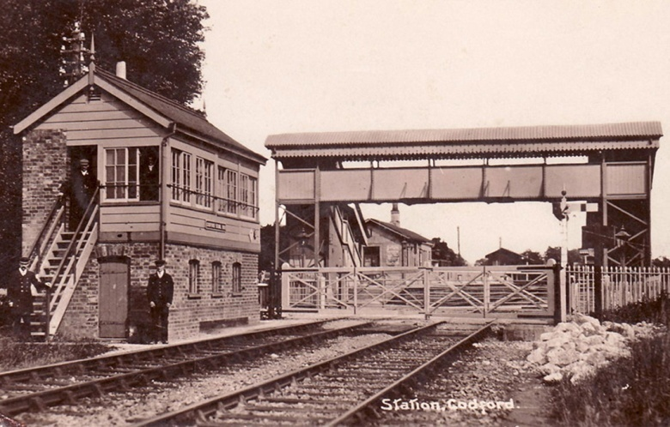
Codford Station

30^{th.} Arrived Le Havre 4 a.m. Light of stars and windows of tall pale houses and electric arcs on quay. March through bales of cotton in sun to camp. The snow first emptying its castor of finest white. Tents Mess full of subalterns censoring letters. Breakfast at 9.45 a.m. on arrival. Afternoon in Havre, which Thorburn likes because it is French. Mess unendurably hot and stuffy, tent unendurably cold till I got into my blankets. Slept well in fug. Snow at night.
31^{st.} Had to shift our lines in snow. 12 to a tent with 2 blankets each. Ankles bad. Nearly all water frozen in taps and basins. Mess crowded – some standing. Censoring letters about the crossing and the children and ailments etc. at home. Had to to make a speech explaining that men need not be shy about writing familiar letters home. At 'Nouvel Hotel' Havre, while we had tea, waitress kissing a Capt. – and arranging for another visit. 4f. for 2 teas. Battery had to be specially warned against venereal in Havre. Read Sonnets in evening: to bed at 9 to escape hot stuffy room. Officers coming and going. Some faces you just see, remembering once and never again. More fine snow like sago.

FEBRUARY 1917

1^{st.} Freezing and overcast. Hospital train goes through camp (wounded men say we have advanced at N. Chapelle). Battery on route march. I arrange to eat midday ration in tent to save lunch in Mess (2f.50). Guns and stores not here yet. Other officers mostly in Havre but my ankle prevents me. Down in lorry to Ordnance Store for field boots. Snow. Route march, but not for me. I write and censor letters. No fire in the Mess till 3 p.m. Guns are coming today. Detachment reorganised. – Mess fills up. Cockney ranker, with two stars come in and drink standing talking of Singapore and Pekin and duration officers look up. Some rapacious and sneering, some gentle. Read sonnets.

2^{nd.} A still colder night and my new boots hurt my ankles like the old. Tried to get shoes from Ordnance in vain. Rode past quays, stores of hay, grain, cotton etc. – cattle – German prisoners – French sentries hooded with long loose cloaks and long rifles and curved bayonets. Afternoon into Havre to look for low shoes – but all too tight: bought low soft boots. Tea in teashop with Thorburn. In a hole over value of English shillings. Bought a good root stick with leather sling for 2f.50. Hard clear night again. All other officers out. Argument with Thorburn about morals, shame, whether poets must go through not only 'sin' but 'repentance' – Dante, Shakespeare. Cold supper in our cold tent – iron ration and cheese and marmalade.

3^{rd.} Not quite so cold. Over hauling guns and rearranging stores on roadside by camp. A pleasant change, but not very much for me to do. Shall the guns be George, Andrew, Patrick, David? Again on the guns in afternoon. 236 Battery leave tonight: most of the officers are in Havre ignorant. All 244 except Smith dined and wined at the Normandie for 10fr. The view is that it could possibly be better placed. Back to Rest Camp 9.30 – great stark ships black with level flecked snow below and big engines and troops arriving.

4^{th.} Cold and bright again. Took the section sliding, then work on guns. At 11 came warning to move at 5.30. Packing, Censoring. New servant – Taylor. Asked if he had done anything of the kind before, said 'I've a wife and family and know what comforts are'. Started at 4.45 for station with guns – held up 1 ½ hours by train across road – 2 hours at station doing nothing. 1 ½ hours entraining guns – platform all cotton bales and men singing 'The nightingales are singing in the pale moonlight'. ('There's a long long trail awinding'). Sgt. Major did practically all the work. – The long waiting before the train starts – men quite silent after comic cries of 'All tickets' and imitating cattle (35 men in each cattle truck; we have a compartment to 2 officers). As we start at 11 suddenly the silent men all yell 'Hurray' but are silent before we clear of long desolate platform of cotton and trampled snow and electric light.

5^{th.} At 7 a.m. after many stops and starts we were close under partly wooded chalk hills, army railway trucks, and near a village with here and there an upper storey quite open like a loft. Snow. Gradually flatter and poplars regular as telegraph poles, orchards, level crossings, children. Buchy at 10 a.m. – Y.M.C.A. – Leave train. Nearly lost train. Fine snowfall. Furzy cuttings. Mistletoe in field. Poplars by Alaincourt. Amiens at 2 and train left a score of men behind for a time. Pale sky and crimson sun at sunset. Doullens at 8. Guns all the time. Night with Thorburn at Guesthouse. Thorburn had been very worried on journey – by things like tunnels while shaving – then by dirty stories after tea. A restless night.

6^{th.} Still very cold. Men had only just drawn rations at 10 when parade was. Much ice on road and pavement. Hanging about in cafés or cold Resthouse. Fine dusty cold day. 2.50fr. breakfast; 6fr. lunch. Horton's amusing jaunty talk full of old army proverbs and metaphors and 'I mean to say'. Letter to Helen. No letters received since Codford. Suddenly at 7.30 we have to shift to Mondicourt without guns – I go on in lorry and choose billets – all in half-ruined barns – barns and farms here are a quad, entered through high arch and self-complete. We've got an elephant sergeants' mess to sleep in. Bitter cold, this being highest in Northern France. Roads ice and frozen snow. Farmyards all frozen. Kaffirs digging.

7^{th.} Bright cold. Horton's way of suddenly saying 'I will arise and go to my Father and say form fours'. Indoors, mostly talking silly, arranging mess funds etc. – I being secretary – cooking our dinner. Battery on short route march. We are to move up very soon. A very merry evening.

8^{th.} Weather as before. Physical drill, a hasty Welsh Rabbit with honey, and then off in lorries through Alaincourt, Barly, Fosseux, to Berneville – men billet in huge barn of a big uneven farmyard surrounded by spread arched stone barns and buildings with old pump at one side, kitchen at upper end. We forage. Enemy plane like pale moth beautiful among shrapnel bursts. A fine ride over high open snowy country with some woods. Rigging up table in mess and borrowing crockery. The battery is split for the present: Rubin has taken guns to Saulty. We are for Dainville. A scramble dinner of half cold stuff, mostly standing. Taylor makes a table and says 'Very good, Sir' and 'It's the same for all. You gentlemen have to put up with the same as us'. Bed early. Rubin returns late. Heavy firing at night. Restless.

9^{th.} Bright bitter cold. Rubin and Smith move off to join 146. Heavy firing near. Afternoon marched through Warlus to Dainville, billets on Arras road, with shell holes behind. Bitter cold. Tea with 146. Beds in the mess for night. (Remember Berneville courtyard, with ruined pigeon house by well and church behind and what was the manor house). Graveyard for 3 'Mort pour la patrie' below our billet. A wonderful night by all the stars and low full moon. Officers of trench mortar battery detained here dine with us on bully, cheese and white wine

10^{th.} Slept warm. Making latrines. With Debenham of 146 to see O.P.s and what was visible from them – through Achicourt and over railway towards Beaurains. One dead man under railway bridge. Maison brulé dangerous. Map, field glass and compass over snowy broken land with posts and wires and dead trees. No infantry visible in our lines or Germans, except those we passed in trenches – Somersets and Cornwalls. Cloudy night and light wind but no thaw yet.

11^{th.} Milder and misty first – sun warm at noon. Maps in morning. Afternoon with digging party at our position by Faubourg, Amiens at southern edge of Arras in an orchard. After tea paid the battery for first time in France. Tested compass bearings by map. Cold. Rubin influenza. Thorburn to Arras. No letters yet. Censoring as usual. Gramophone playing 'Wait till I am as old as father' and 'Where does daddy go when he goes out?' 9 p.m. Great cannonade thudding and flashing quite continuously away South in Ancre.

12^{th.} Disappointed in not going again on trench Reconnaissance. Maps in morning. Working party at gun position in afternoon. Got a chill and was very weary. Thorburn and Rubin have colds. Evening as usual censoring men's letters. Half battery moves to Faubourg d'Amiens – Thorburn there too, thank God. Smith back from Saulty – no news of our letters or lorries. Not much firing near us today, but 146 lost a man killed and one wounded. Gramophone plays the rotten things and then Gounod's 'Ave Maria' and 'Dormez Vous' which makes us rather silent after smut.

13^{th.} Awoke tired and cold though it is thawing and cloudy with a breeze. No work this morning, but I pore over map and think how I may enjoy doing it when this is all over, which is not a good feeling, I suspect, Taylor says (as he makes my bed and as usual asks if he does it right): 'I am not proud, but I likes to be comfortable. I have been domesticated since I joined the Army.' Nothing to do all morning, afternoon at our position – hare, partridges and wild duck in field S.E. of guns. I feel the cold – the morning sun turns to a damp thaw wind.
Letters home to Father, Mother and Eleanor. Some grass showing green through melting snow. Thorburn worries because he can't laugh at silly low talk. Evening censoring letters and reading Sonnets; others writing – when I begin to talk to Rubin, the Captain said 'You get on with your Sonnets' and then all was silent. Awful fug.

14^{th.} A bad night but feeling better. All day with Horton, and then Horton and Smith, examining O/Ps above Agny and Wailly, and then between Achicourt and Beaurains. Fine sunny day – snow melting. Black-headed buntings talk, rooks caw, lovely white puffs of shrapnel round planes high up. Right section does aeroplane shoot in afternoon. Dead campion umbels, and grass rustling on my helmet through trenches. Pretty little copse in deep hollow high up between Ficheux and Dainville, where guns look over to Berneville and Warlus.

15^{th'} With Captain observing for a BT. Shoot on Ficheux Mill and edge of Blairville Wood. Fine sun but cold in trench. With working party in afternoon. Letters arriving at 6. We sorted them and then spent an hour silently reading. 750 for men; 17 for me – from Helen, the children, Father, Mother, Eleanor, Freeman, Mrs. Freeman, Guthrie, Vernon and Haines. Evening, reading or writing letters. A quiet evening, indoors and out. Taylor says as he mends the fire, 'Well, we have to put up with many discomforts. We're all alike, Sir, all human.' A still starry night with only machine guns and rifles. Slept badly again, and then suddenly with no notice got up from breakfast on the
16^{th.} to do fire control on aeroplane shoot (only 10 rounds, observation being bad). Dull day. Left Thorburn on guns at 11.30. Bad temper. Afternoon up to O.P., but too hazy to observe. A mad captain with several men driving partridges over the open and whistling and crying 'Mark over'. Kestrels in pairs. Four or five planes hovering and wheeling as kestrels used to over Mutton and Ludcombe. Women hanging clothes to dry on barbed entanglement across the road. Rain at last at 4.15. This morning the old Frenchman living in this ruin burst into our room while we were dressing to complain of our dirt and depredation, and while Rubin was rude in English, said he was a Frenchman and had been an officer. Nobody felt the slightest sympathy with his ravings, more than with the old white horse who works a mill walking up and up treadmill.

17^{th.} A dull muddy day. No observation, no shooting. On guns all day and in dug-out, writing up our fighting book. Another letter from home. Could only just see A.P. Kit arrived last night. I slept badly, coughing. Very mild and the roads chalk and water, Grandes Graves 2.50 a bottle. Thorburn asks where he shall put the letters he has censored – decides on the crowded table – then I tell him the mantelpiece is the obvious place.

18^{th.} Another dull day down in 146 Dug-out. Afternoon to Arras – Town Hall like Carreg Cennin. Beautiful small white square empty. Top storey of high house ruined with armchair and a garment across it left after shell arrived. Car to Mendicourt and back by light of star shells. Shopping at Bellevue B.E.F. canteen. Returned to find I am to go as Orderly Officer to Group 35 H.A. in Arras tomorrow.

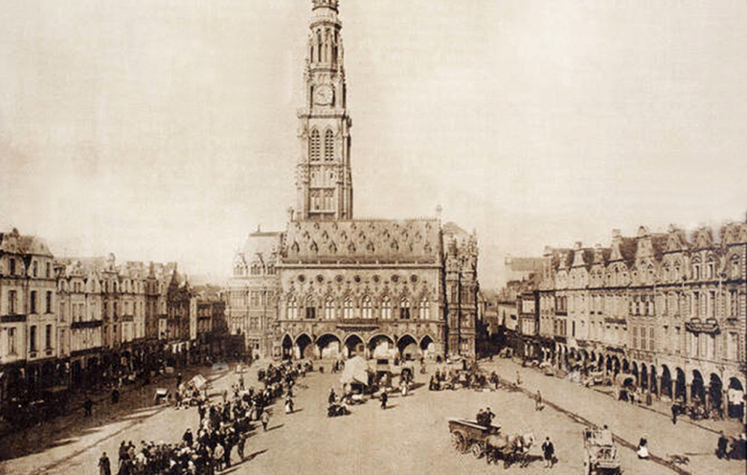
Arras Town Hall

19^{th.} To Arras and began showing sectors and arcs on 1/10000 maps. Field cashier's; waiting in long queue of officers to cash cheques etc. Learning office work. Place Victor Hugo white houses and shutters and sharpened fuller and dome in middle. Beautiful. In class it was like Bath – retired people, schools, priests. Gardens, courtyards, open spaces with trees. I still funk the telephone and did not use it once today. Sentries challenge in street and answer 'Sussex' etc.

20^{th.} Rain. To Ferreux in the car for cash and gas helmets. Rain and mud and troops and Hun prisoners and turbaned Indians at a barn door holding a sheep by a rope round its neck, all still and silent. Afternoon through Ferreux again with Col. Witchall to Mendicourt in rain and mud and back in darkness along main Arras Road – could usually only see 2 or 3 of the roadside trees except when we ran into the blaze of 18- pounders battery by the roadside. Blast of 18-pounders near the billet blew mortar from ruins against our window linen. Called at 244 for letters – none. C/O and Berrington and Cassells as before sat up till 12.30 and I could not go to bed before.

21^{st.} Clearer and no rain. Checking inventory of new billet in fine modern house at corner of Rue de l'Abbé Hallain and Boulevard Vauban. Big vacant house, red brick and shutters, oak floors, panelling and pictured ceilings and mirrors – a few beds, chairs and tables left. A small backyard with a few trees and grass. We supplant Cameronians. One ruined house has still an engraved 1850 portrait hanging on wall high up, without glass broken. Rubin brought in letters from Helen and Eleanor. Hung on at billet till telephone connection was made at new. It being very cold, we got to bed at 11.30.

22^{nd.} Cold and wet. Fuel damp. Office work and maps. Court of Inquiry on gassing of 4 men. Am I to stay on here and have nothing but cold feet and ask Cassells What is to be done? No thrushes yet, but a chaffinch says 'Chink' in the chestnut in our garden. Pipits sing up at Dainville, where I have come to see 244, but they are all out – they came in, all but O/C, and we had tea, and Rubin drove me back. Letter from Father – Evening in Mess with Wallace as guest. Cold and still: no artillery all day. At night I quite thought someone was knocking excitedly at one of the doors, when it was really machine guns. Troops going out to trenches singing and whistling 'It's nice to get up in the morning' or a thing with part of 'The Minstrel Boy' tune in it.

23^{rd.} Chaffinch sang once. Another dull cold day. Inspected stables, checked inventory of new billet for men in Rue Jeanne d'Arc, went with Colonel round 244, 141 and 234 positions and O.P. in Achicourt. Afternoon maps. Partridges twanging in fields. Flooded fields by stream between the 2 sides of Achicourt. Ruined churches, churchyard and railway. Sordid ruin of Estaminet with carpenter's shop over it in Rue Jeanne d'Arc – wet, mortar, litter, almanacs, bottles, broken glass, damp beds, dirty paper, knife, crucifix, statuette, old chairs. Our cat moves with the Group wherever it goes, but inspects new house inside and out, windows, fireplace etc. Paid the Pool gunners (scrapings from several batteries doing odd jobs here).2 owls in garden at 6. The shelling must have slaughtered many jackdaws but has made home for many more. Finished Frost's 'Mountain Interval'. Wrote to Frost. A quiet still evening. Rubin brought over letter from Helen and Oscar.

24^{th.} Why do Huns not retaliate on Arras guns? Some day this will be one of the hottest places this side of Hell, if it is this side. Nothing to do here today. Clearer, but still dull and cold with more breeze. Gas Alert off. Wrote to Father. Lushington calls and goes out with Colonel. Dined with 244 and Major Berrington and Capt. Angus – a dull long meal with maraschino chocolates at end, Benedictine, whisky and coffee, after soup, hors d'oeuvres, tinned turkey, roast mutton, Christmas pudding, apricots and cream. Gramophone but no fun. Walked back to Arras in dark with Thorburn, challenged by only 2 sentries who were content with 'Friend' though they could not see a yard among the ruins. Owls on Dainville Road. Machine guns and hanging lights above No-Man's-Land. Cassells and Colonel alone up when I returned at 11. New moon – last as I walked from Hatch to Codford.

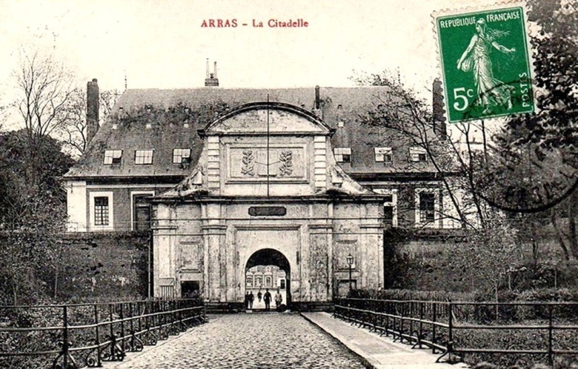
La Citadelle d'Arras

25^{th.} A dull morning turns sunny and warm. Chaffinches and partridges, moles working on surface. Beautiful 18th century citadel with church ruined in middle of great barrack square. Huge bastions with sycamores in moat and tangled grass. Walked over citadel to new position with Colonel. Talked to Horton in our orchard. Wrote to Oscar. Artillery lively in the clear sunny noon. I got hot and spring-languid walking up at 4.30 to 244. Gramophone here played 'Anitra's Dance', 'Death of Troll' and 'Allanwater'. Does a mole ever get hit by a shell?

26^{th.} A clear morning. 8.15 – 9.30 an incessant field gun firing – raid – German prisoners back at 10.15. Sunshine in white ruins and white squares with Scots standing about. A few shells arrive in Arras, but nobody looked as if anything were happening. While our guns were firing we could not hear one another speak. Afternoon to Achicourt to see if a gun position was visible to Huns. Shells and machine gun bullets came over. An 18-pounder on a fire point fired when I was 3 yards off (in front). Fitting aeroplane photos together. Paid out. A sunny day but cold in the house. Wrote to G. Bottomley. Gramophone. Talk with Berrington and Colonel.

27^{th.} Fine but chilly. 2 English planes fell, one on fire, as I walked up to 244 in afternoon: machine gun bullets cut telephone wire close by. Letters from Helen and Irene. Nothing to do but go and see about a billet of 244's collared by another Battery. Tea at 244 after seeing 2 of our planes down, one on fire with both burnt to death after alighting. Letters from Helen, Irene and Eleanor.

28^{th.} 244 to go into position. Out identifying gun positions. Up to 244 to pack for a change of billet. Tea with Rubin. Thorburn, Lushington and Horton. Letter from Helen, parcel from Mother. Shelling town at night. Walk out to Dainville by citadel and marsh – moorhens in clear chalk stream by incinerator; blackbirds too, but no song except hedge-sparrow. Evening, ruin with Colonel and Cassells.

MARCH 1917

1^{st.} Sunny and breezy. Wrote to Helen, Mother, Eleanor and Ellis. Indoors all morning doing nothing. Mostly a quiet morning. Out with Berrington round the marsh towards 244 who were doing their 1st shoot. Enemy planes over. 2 rounds across 244 position on to Doullens Road. Great deal of ant-aircraft shells singing by. Sat down on hill above 244 and watched German lines. At Beaurains ghastly trees and ruins above Achicourt church tower. A bullet passes. Quite warm to sit down for quarter hour. Evening in mess. Colonel talks of the General (Poole) who was all for 'Fire, fire, fire!' Loose her off! Deliver the goods! Annoy the Hun.' With artillery shelling heavy from about 5 a.m. I only dressed because I thought it would be better to have my clothes on. In any case I had to be up at 6 to go to Achicourt. A very misty still morning: could see nothing from bedroom except the trees and the stone dog – our artillery really made most of the noise, and I being wakened and also inexperienced mistook it.

2^{nd.} Up at 5.30 and went to Achicourt Chateau to see 141's gun into its forward position. A misty frosty morning luckily and no plane could observe. Afternoon to Faubourg Ranville, its whistling deserted ruined streets, deserted roadway, pavement with single files of men. Cellars as dug-outs, trenches behind and across road. Dead dry calf in stable. Rubble, rubbish, filth and old plush chair. Perfect view of No Man's Land winding level at foot of Hun slope, and Beaurains above to one side and woods just behind crest on other side (M.B.110). With Horton and Lushington to see 3 O.P.s there:- Letters from Helen, Mother, Eleanor and J. Freeman.

3^{rd.} [E.T.'s 39th birthday] No post. Morning dull spent in office. But afternoon with Colonel to Achicourt to see O.P.s and then to new battery positions. A chilly day not good for observing. Court of Inquiry on a man burnt with petrol – Lushington presiding and afterwards I went back with him to 244's billet and saw my new quarters to be. Wrote to Mother and Helen.

4^{th.} Cold but bright clear and breezy. Nothing to do all morning but trace a map and its contours. Colonel and I went down to 244 before lunch to see the shell holes of last night and this morning. Hun planes over. More shells came in the afternoon. The fire is warm but the room cold. Tea with Lushington and Thorburn. Shelling at 5.30 – I don't like it. I wonder where I shall be hit as in bed I wonder if it is better to be on the window or outer side of the room or on the chimney or inner side, whether better to be upstairs where you may fall or on the ground floor where you may be worse crushed. Birthday parcels from home.

5^{th.} Out early to see a raid by VI Corps, but snow hid most but singing of Field shells and snuffling of 6". – Ronville's desolate streets. To 244's orchard which has had numerous 4.2 shells over, meant for the road. Wrote to Helen, Mervyn and Bronwen. Afternoon indoors paying etc. After tea to 244 to dine, not very happy with Lushington, Horton and Smith. They have the wind up because of the shells (which may have been meant for the road behind). Letters from de la Mare, Helen, Bronwen and de la Mare. A beautiful clear moonlit night after a beautiful high blue day with combed white clouds.

6^{th.} Bright and clear early and all day and warm at 1. Walked over to 244's position with Colonel and then up to 234 beyond Dainville station, and listened to larks and watched aeroplane flights. 2 planes down, one in flames, a Hun. Sometimes 10 of our planes together very high. Shells into Arras in afternoon.

7^{th.} A cold raw dull day with nothing to do except walk round to 244 to get a pair of socks. The wind made a noise in the house and trees and a dozen black crumpled sycamore leaves dance round and round on terrace. Wrote to Pearce and Irene. Rather cold and depressed and solitary.

8^{th.} Snow blizzard – fine snow and fierce wind – to Achicourt O.P. but suddenly a blue sky and soft white cloud through the last of the snow – with Colonel and Berrington. Returned to hear that the Group has to leave this billet. I liked the walk. Indoors afternoon fitting together aeroplane trench photographs. Letters from Helen, Eleanor, Oscar and Frost (saying he had got an American publisher for my verse). A still quiet night up to 11 with just one round fired to show we have not left Arras. Up till 1 for a despatch from Corps. Colonel snotted interpreter.

9^{th.} Snow and very cold indoors doing nothing but look at a sandbag O.P. My last day at the Group. Weir of 2/1 Lowland takes my place. I return to 244 – Lushington, Horton and Rubin. I am fed up with sitting on my arse doing nothing that anybody couldn't do better. Wrote to de la Mare, Frost and Eleanor.

10^{th.} Up at 5.45 for a raid, but nothing doing. A misty mild morning clearing slightly to a white sky. 10 rounds gunfire C-B. Snowdrops at foot of pear trees by Decanville Railway. R.F.C. wireless man reading 'Hiawatha'. 3 shoots of 10 rounds gunfire suddenly at N.F. targets unobserved. Men mending a caved-in dugout in the dark. Parcel from Janet Hooton.

11^{th.} Out at 8.30 to RonvilleO.P. and studied the ground from Beaurains N. Larks singing over No man's Land – trench mortars. We were bombarding their front line: they were shooting at Arras. R.F.A. officer with me who was quite concerned till he spotted a certain familiar Hun sentry in front line. A clear, cloudy day, mild and breezy. 8th shell carrying into Arras. Later Ronville heavily shelled and we retired to dugout. At 6.15 all quiet and heard blackbirds chinking. Scene peaceful, desolate like Dunwich moors except sprinkling of white chalk on the rough brown ground. Lines broken and linesmen out from 2 .30 to 7 p.m. A little rain in the night; …

12^{th.} …then a beautiful most clear limpid early morning till the Raid at 7 and the retaliation on Ronville at 7.30 - 8.45 with 77 cm. 25 to the minute. Then back through 6 ins. of chalk mud in trenches along battered Ronville Street. Rooks in tall trees on N. side of Arras – they and their nests and the trees black against the soft clouded sky. W. wind and mild but no rain yet (11 a.m.). Letters, mess accounts, maps. Afternoon at maps and with Horton at battery. Evening of partridges calling and pipsqueaks coming over behind.

13^{th.} Blackbird trying to sing early in dull marsh. A dull cold day. One N.F. shoot at nightfall. I was in position all day. Letters from Eleanor, Mother and Ellis: wrote to Bronwen, Mother and Eleanor,

14^{th.} Ronville O.P. Looking out towards No Man's Land what I thought first was a piece of burnt paper or something turned out to be a bat shaken at last by shells from one of the last sheds in Ronville, A dull cold morning, with some shelling of Arras and St. Sauveur and just 3 for us. Talking to Birt and Randall about Glostershire and Wiltshire, particularly Painswick and Marlborough. A still evening – blackbirds singing far off – a spatter of our machine guns – the spit of one enemy bullet – a little rain – no wind – only far-off artillery.

15^{th.} Huns strafe I-sector at 5.30. We reply and they retaliate on Arras and Ronville. Only tired 77s reach OP. A sunny breezy morning. Tried to climb Arras chimney to observe, but funked. 4 shells nearly got me while I was going and coming. A rotten day. No letters for 5 days.

16^{th.} Larks and great tits. Ploughing field next to orchard in mist – horses and man go right up to crest in view of Hun at Beaurains. Cold and dull. Letters to Helen and Janet. In the battery for the day. Fired 100 rounds from 12 - 1.30. Sun shining but misty still. Letter from Bronwen. The first thrush I have heard in France sang as I returned to Mess at 6 p.m. Parcel from Mother – my old Artist boots. Wrote to Hodson. A horrible night of bombardment, and the only time I slept I dreamt I was at home and couldn't stay for tea …

17^{th.} Then most glorious bright clear morning. But even Horton, disturbed by 60-pounders behind his dug-out, came in to breakfast saying: 'I'm not going to stay in this ----- army; the day peace is declared I am out of it like a ----- rabbit'. A beautiful day, sunny with pale cloudless sky and W. wind, but cold in O.P. Clear nightfall with curled cinereous cloud and then a cloudless night with pale stains in the sky over where Bosh is burning a village or something. Quiet till 3: then a Hun raid and our artillery over us meet it: their shells into St. Sauveur, Ronville and Arras. Sound of fan in underground cave.

18^{th.} Beautiful clear cloudless morning and no firing between day-break and 8. Drew another panorama at 7. Linnets and chaffinches sing in waste trenched ground with trees and water tanks between us and Arras. Magpies over No Man's Land in pairs. The old green (grey) track crossing No Man's Land once a country way to Arras. The water green and clear ( Like Silent Pool) – of Moat of the Citadel with skeletons of whole tree lying there. Afternoon washing and reading letters from Helen and Eleanor. I did 2 shoots. News came that we are in Beaurains and near Muscatel. Letters to Helen and Eleanor. The pigeons are about in the streets above Faubourg more than ever and I could hear a lark till the Archies drowned it. Fired 600 rounds and got tired eyes and ears. Then early to bed and up at 4 to go to O.P.

19^{th.} Nothing to do all day at Ronville but look at quiet No Man's Land and trenches with engineers beginning to straighten road up. Back to sleep at billet, but preferred to return to O.P. as I've to go to the front trench O.P. at 4 on the

20^{th.} Stiff mud all the way up and shelled as we started. Telegraph Hill as quiet as if only rabbits lived there. I took revolver and left diary behind in case. For it is very exposed and only a few Cornwalls and MGC about. But Hun shelled chiefly over our heads into Beaurains all night – like starlings returning 20 or 30 a minute. Horrible flap of 5.9 a little along the trench. Rain and mud and I've to stay till I'm relieved tomorrow. Had not brought warm clothes or enough food and had no shelter, nor had telephonists. Shelled all night. But the M.G.C. boy gave me tea. I've no bed. I leant against wall of trench. I got up and looked over. I stamped up and down. I tried to see patrol out. Very light – the only sign of Hun on Telegraph Hill, though 2 appeared and were sniped at. A terribly long night and cold. Not relieved till 8. Telephonists out repairing line since 4 on the morning of the

21^{st.} At last 260 relieved us. Great pleasure to go, be going back to sleep and rest. No Man's Land like Goodwood Racecourse with engineers swarming over it and making a road between shell holes full of bloodstained water and beer bottles among barbed wire. Larks singing as they did when we went up in dark and were shelled. Now I hardly felt as if a shell could hurt, though several were thrown about near working parties. Found letter from Helen, Eleanor and Julian. Had lunch, went to bed at 2 intending to get up to tea but slept till 6.30 on the

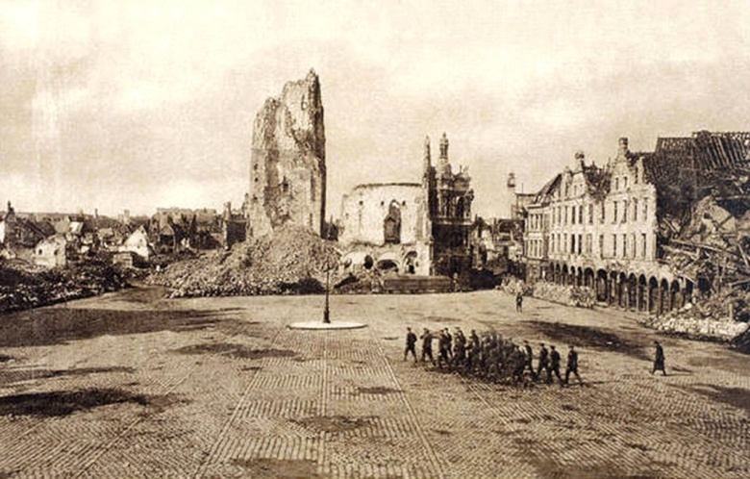
The Town Hall, Arras

22^{nd.} (Beautiful was Arras yesterday coming down from Beaurains and seeing Town Hall ruin white in sun like a thick smoke beginning to curl. Sprinkle of snow today in sun). A cold bright day with snow early. We fired twice. I on duty at battery. Letters to Helen and home and Gordon and Deacon. Partridges twanging in open fields. Not much shooting to do. Several windy snow showers half-hail and then sun. Talk with Thorburn about his fate if he loses his commission. Gramophone plays Ambrose Thomas's 'Mignon' gavotte ( by Raymond Jeremy's Philharmonic Quartette), 'D'ye ken John Peel', Chopin's 'Berceuse', Tchaikovsky's 'Fantasia Italiana'.

23^{rd.} Frosty clear. Ploughs going up over crest towards Beaurains. Rubin back from F.O.P. believes in God and tackles me about atheism – thinks marvellous escapes are ordained. But I say so are the marvellous escapes of certain telegraph posts, houses, etc. Sunny and cold – motored to Avesnes and Fosseux to buy luxuries and get letters. Crowded bad roads through beautiful hedgeless rolling chalk country with rows of trees, some along roads following curving ridges – villages on crests with church spires and trees. Troops, children holding hands and dark skinned women, mud-walled ruined barns. Parcels from Mother and Helen, letters from Mother and J. Freeman.

24^{th.} Out early to Beaurains. The chill clear air pains my skin while it delights my mind – both walking and in the car. Only tombstones recognisable in Beaurains and that little comical summer house among trees. Sat all day in copse in old chalk pit between Agny and Achicourt which is perhaps to be our new position. Warm in the sun, but no thrushes in all those ash, hazel and dogwood. Parcels from Mrs. Freeman and Eleanor. Letters to Mrs. Freeman, Helen and Mother.

25^{th.} Up at 5 and to O.P. beyond Beaurains with Thorburn and stood all day in trench behind hedge till head ached with staring at Wancourt and Neuville-Vitasse and the ground between and beyond. A cold but sunny day. Many R.F.A. and infantry used the O.P. We were discovered and the O.P. 20 yards away had a shell on it, and we had several over our shoulders. Larks singing. Drawing panoramas. Left Thorburn there at 6 p.m. Tired enough. Letters from Bronwen, Trevelyan and Guthrie.

26^{th.} Preparing reports and panoramas for 35 H.A.G. Rainy and dull. Letter to Bronwen. Packing up for move to the chalk pit. Up late in emptied billet waiting for ASC lorries to come up. Off at last on foot to the Achicourt billet at 1, in white cordite flashes in dark roads.

27^{th.} Rain and sleet and sun, getting guns camouflaged, stealing a Decanville truck, laying out night lines. Letters from Hodson, Eleanor and Sgt.Pellissier. Still that aching below nape of my neck since my last O.P. day. Sat till 11 writing letters. As I was falling asleep great blasts shook the house and windows, whether from our own firing or enemy bursts near, I could not tell in my drowse, but I did not doubt my heart thumped so that if they had come closer together it might have stopped. Rubin and Smith dead tired after being up all the night before. Letters from Helen and Eleanor.

28^{th.} Frosty and clear and some blackbirds singing at Agny Chateau in the quiet of exhausted battery, everyone just having breakfast at 9.30: all very still and clear: but these mornings always very misleading and disappearing so that one might almost think afterwards they were illusive. Planes humming. In high white cloud aeroplanes leave tracks curving like rough wheel tracks in snow – I had a dream this morning that I have forgot but Mother was in distress. All day loading shells from old position – sat doing nothing till I got damned philosophical and sad. Thorburn dreamt 2 nights ago that a maid was counting forks and spoons and he asked her 'Must an officer be present'. Letter to Helen. Tired still.

29^{th.} Wet again. Getting refuge trenches dug for detachments. Marking crests on maps. How beautiful, like a great crystal sparkling and spangling, the light reflected from some glass which is visible at certain places and times through a hole in cathedral wall, ruined cathedral.

30^{th.} Bright early, then rain. New zero line, planting pickets. Arranging material for new O.P. dugout – old one fell in yesterday. Clear and bright and still from 6 p.m. on. Air full of planes and sound of whistles against Hun planes. Blackbirds singing then chuckling as they go to roost. Two shells falling near Agny Chateau scatter them. Letters from Helen and Mother and parcels from Mother and Eleanor. Too late to bed and had no sleep at all, for the firing, chiefly 60-pounders of our own. Shakespeare plays for 10 minutes before sleep.

31^{st.} Up at 5 worn out and wretched. 5.9s flopping on Achicourt while I dressed. Up to Beaurains. There is a chalk-stone cellar with a dripping Bosh dugout far under and by the last layer of stones is a lilac bush, rather short. Nearby is a graveyard for the 'tapferer franzoz soldat' with crosses and Hun names. Blackbirds in the clear cold bright morning early in black Beaurains. Sparrows in the elder of the hedge I observe through – a cherry tree just this side of the hedge makes projection in trench with its roots. Beautiful clear evening everything dark and soft round Baiville Ulaise, after the rainbow there and the last shower. Night in lilac-bush cellar of stone like Berryfield. Letter to Helen. Machine gun bullets snaking along – hissing like wormy serpents.

APRIL 1917

1^{st.} Among the ragged and craggy gables of Beaurains – a beautiful serene clear morning with larks at 5.15 and the blackbirds at 6 till it snowed or rained at 8. All day sat writing letters to Helen, Father and Mother by the fire and censoring men's letters etc., an idle day – I could not sleep till I went to bed at 10. Letters from Helen, Baba and Deacon. A fine bright day with showers.

2^{nd.} Letter to H.K. Vernon. Another frosty clear windy morning. Some sun and I enjoyed filling sandbags for dugout we to have in battery for the battle. But snow later after we had fired 100 rounds blind. Snow, half melting as it falls, makes fearful slush. I up at battery alone till 9.30 p.m. Writing to Helen and Frost. Rubin and Smith sang duets from 'Bing Boys' till 11.

3^{rd.} Snow just frozen – strong S.E. wind. Feet wet by 8.15 a.m. Letters from Gordon and Freeman. The eve. Letters to Gordon, Freeman, Helen. A fine day later, filling sandbags. MACBETH.

4^{th.} Up at 4.30. Blackbirds sang at battery at 5.45 – shooting at 6.30. A cloudy fresh morning. But showery cold muddy and slippery later. 600 rounds. Nothing in return yet. Tired by 9.15 p.m. Moved to dugout in position. Letter from Helen. Artillery makes air flap all night long.

5^{th.} A dull morning turns misty with rain. Some 4.2s coming over at 10. Air flapping all night as with great sails in strong gusty wind (with artillery) – thick misty windless air. Sods on f/C's dugout begin to be fledged with fine green feathers of yarrow – yarrow. Sun and wind drying the mud. Firing all day, practising barrage etc. Beautiful pale hazy moonlight and the sag and flap of air. Letters to Mother and Helen. HAMLET.

6^{th.} A lazy morning, being a half day: warm and breezy, with sun and cloud but turned wet. Billets shelled by 4.2: 60-pounders hit. In car with Horton to Fosseux and Avesnes and met infantry with yellow patches behind marching, soaked, up to the line – band and pipes at Wanquetin to greet them, playing 'They wind up the watch on the Rhine' (as Horton calls it). After the shelling Horton remarks: 'The Bosh is a damned good man, isn't he, a damned smart man, you must admit'. Roads worse than ever – no crust left on side roads. Letters from Helen, Mervyn, Mother, Eleanor.

7^{th.} Up at 6 to O.P. A cold bright day of continuous shelling N. Vitasse and Telegraph Hill. Infantry all over the place in open preparing Prussian way with boards for wounded. Hardly any shells into Beaurains. Larks, partridges, hedgesparrows, magpies by O.P.
A great burst in red brick building in N. Vitasse stood up like a birch tree or a fountain. Back at 7.30 in peace. Then at 8.30 a continuous roar of artillery.

8^{th.} A bright warm Easter day but Achicourt shelled at 12.30 and then at 2.15 so that we all retired to cellar. I had to go over to battery at 3 for a practice barrage, skirting the danger zone, but we were twice interrupted. A 5.9 fell 2 yards from me as I stood by the f/C post. One burst down the back of the office and a piece of dust scratched my neck. No firing from 2 - 4. Rubin left for a course.

The following day, the first day of the 2nd. Battle of Arras, Edward Thomas was killed while directing fire at the 244 battery O.P.
To spare the feelings of his widow Helen, she was told Thomas was killed by the concussive blast wave of a shell and that there was no mark on his body. However, a letter from his commanding officer Franklin Lushington, written in 1936, states the cause of Thomas's death was
being "shot clean through the chest".

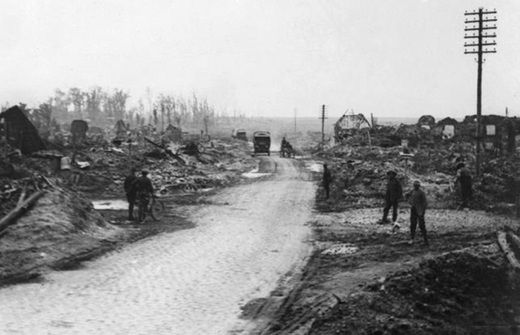
Cemetery Road, Beaurains

The Observation Post where Edward Thomas was killed
was just off Cemetery Road, Beaurains.

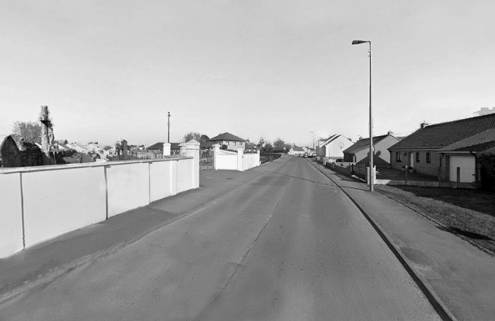

Cemetery Road, 2022, now renamed Route de Tilloy. The
cemetery can be seen on the left

AS THE TEAMS HEAD BRASS

As the team's head brass flashed out on the turn
The lovers disappeared into the wood.
I sat among the boughs of the fallen elm
That strewed the angle of the fallow, and
Watched the plough narrowing a yellow square
Of charlock. Every time the horses turned
Instead of treading me down, the ploughman leaned
Upon the handles to say or ask a word,
About the weather, next about the war.
Scraping the share he faced towards the wood,
And screwed along the furrow till the brass flashed
Once more. The blizzard felled the elm whose crest
I sat in, by a woodpecker's round hole,
The ploughman said. 'When will they take it away?'
'When the war's over'. So the talk began –
One minute and an interval of ten,
A minute more and the same interval.
'Have you been out?' 'No'. ' And don't want to, perhaps?'
'If I could only come back again, I should.
I could spare an arm. I shouldn't want to lose
A leg. If I should lose my head, why, so
I should want nothing more…. Have many gone
From here?' 'Yes.' 'Many lost?' 'Yes, a good few.
Only two teams work on the farm this year.
One of my mates is dead. The second day
In France they killed him. It was back in March,
The very night of the blizzard, too. Now if
He had stayed here we should have moved the tree.'
'And I should not have sat here. Everything
Would have been different. For it would have been
Another world.' 'Ay, and a better, though
If we could see all all might seem good.' Then

The lovers came out of the wood again:
The horse started and for the last time
I watched the clods crumble and topple over
After the ploughshare and the stumbling team.

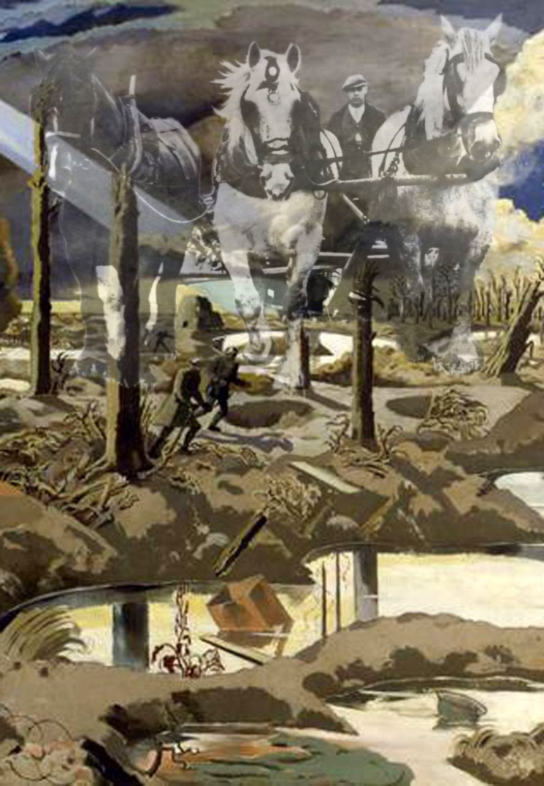
Illustration: Robert Tilleard

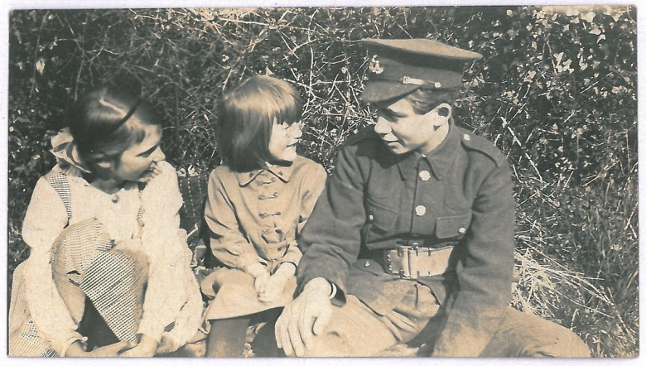

Bronwen – 'Roses,Pyrgo and Lapwater, -
I shall give them to my elder daughter.'
Myfanwy – 'But leave her Steep and her own world
And her bespectacled self with her hair uncurled'. Mervyn – 'Martins, Lambkins, or Lillyputs,
Should be his till the cart tracks had no ruts.'

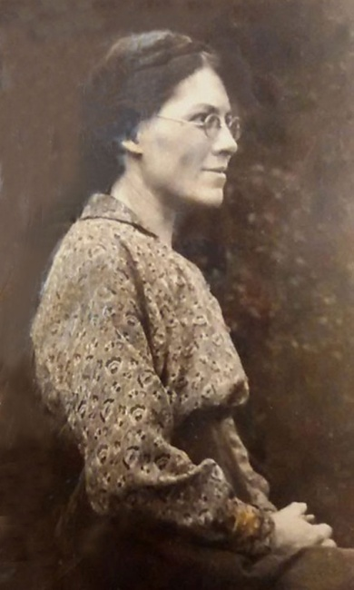
Helen Thomas
AND YOU HELEN

And you, Helen, what should I give you?
So many things I would give you
Had I an infinite store
Offered me and I stood before
To choose. I would give you youth,
All kinds of loveliness and truth,
A clear eye as good as mine,
Lands, waters, flowers, wine,
As many children as your heart
Might wish for, a far better art
Than mine can be, all you have lost
Upon the travelling waters tossed,
Or given to me. If I could choose
Freely in that great treasure-house
Anything from any shelve,
I would give you back yourself,
And power to discriminate
What you want and want it not too late;
Many fair days free from care
And heart to enjoy both foul and fair,
And myself, too, if I could find
Where it lay hidden and it proved kind.

