1

THE GIRL FROM LACOCK

The inclination to ask her her name
To satisfy a curiosity
Is defiantly met with a blank stare.
There is no Aphrodite to melt this
Galatea into a living nymph,
So - though not her maker - I may kiss her.
The church is named for Saint Cyriac
Who had to cast out demons in a girl,
But she doesn’t look the type of maiden
Who once entertained the Prince of Darkness.
She’s neither a simple Virgin Mary
Nor a lady of the nearby manor,
But I’d like to think she’s a village girl,
Lover of the local Pygmalion,
Who caressed and fashioned the yielding stone
And, when she was living flesh, did kiss her.

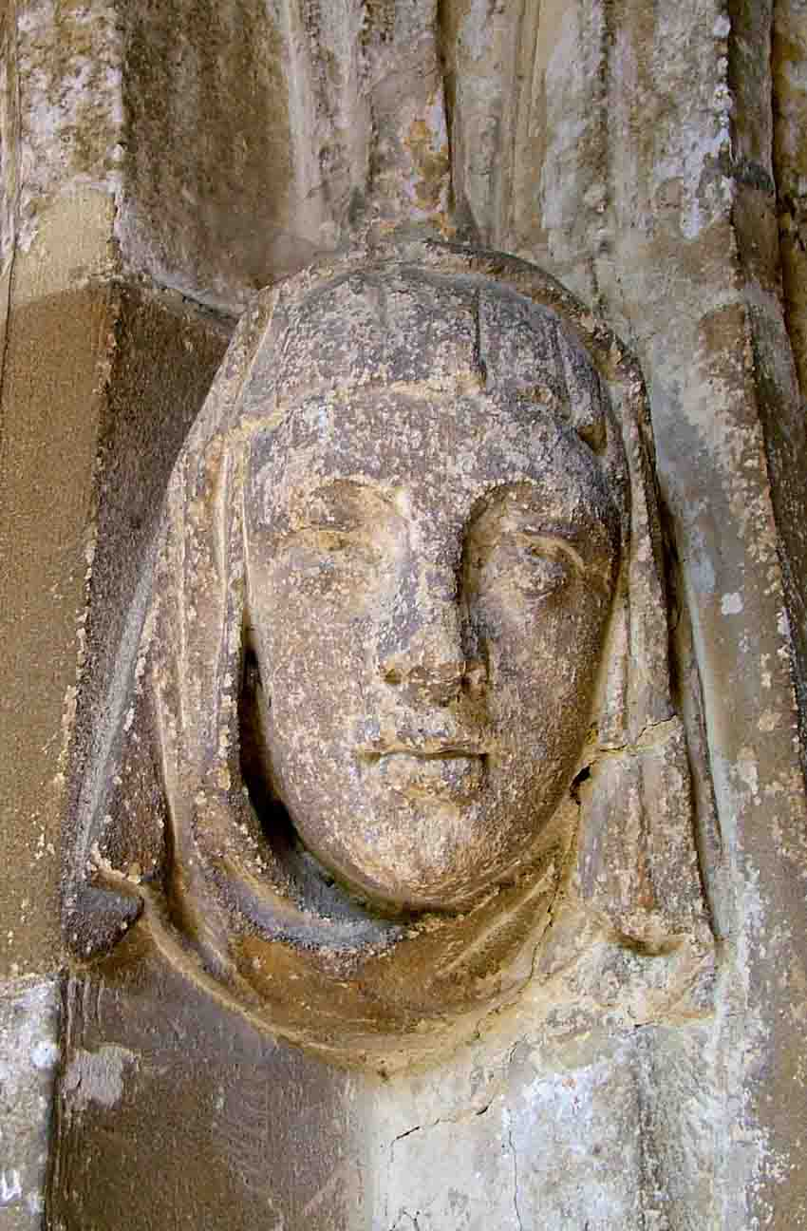

2

THE BIRD or L’Uccelo nel Cielo

My friend says it’s far too high to tell
Whether a buzzard
or a kestrel;
Whatever bird of prey it calls itself
It likes the mountains this hunting bird,
And now the jagged roofline provides
By shadowing walls as Apennines.
It pauses for Zeus to make a sketch
So the blue sky can take the bird’s wing
It mimics, and echoes, and parrots.
As it looks down watchfully on this
Gravity ensnared Umbrian street
Gaia sketched in for Man to follow
His ordained undulating blueprint,
Merging earth with the empyrean.

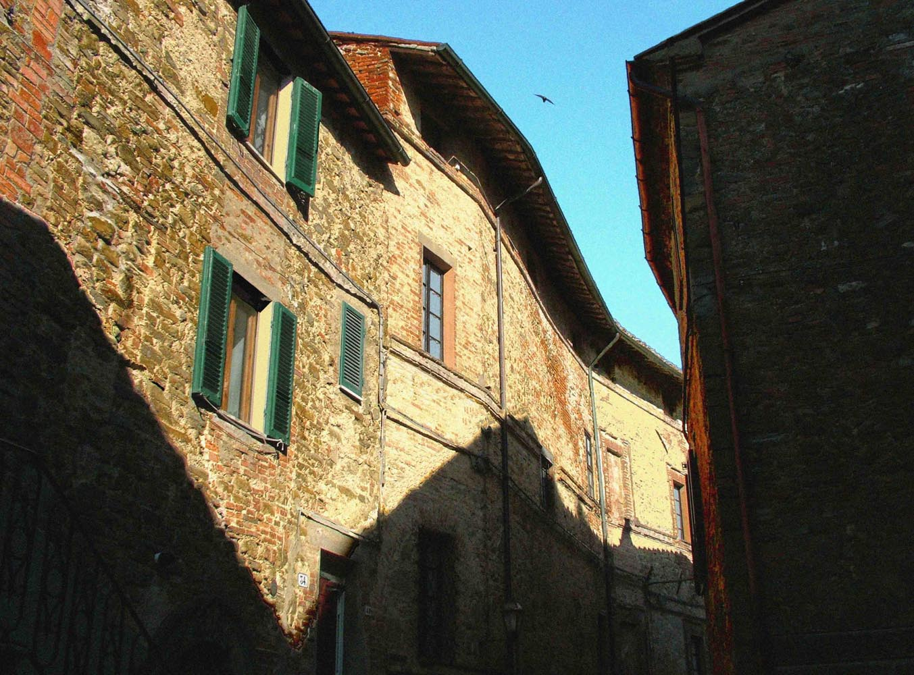

3

LA FONTANA

This travertine marble has travelled far.
It was thirsty work those two hundred miles,
Those eight hundred feet from quarry to here;
All those heights above undrinkable water.

Under the burnt streets of this hilltop town
This cooling water will spill from a wound
Neptune made in the side of the mountain.
We, with our dried-up throats, cannot yet drink
From this fresh source of our own devising –
The naiads are playing with Tantalus.
We kneel with hope on the stone steps and pray,
But that pale-faced chalice remains unfilled.

Years pass and the fountain gives of its gift
To those who need help and ask for relief.
Now our thirsty work has been forgotten
When we return and find the fountain dry.
But today our prayers are heard nearby,
For there is a small bar across the square
Where mischievous naiads are forbidden
And water comes in bottles, not fountains.

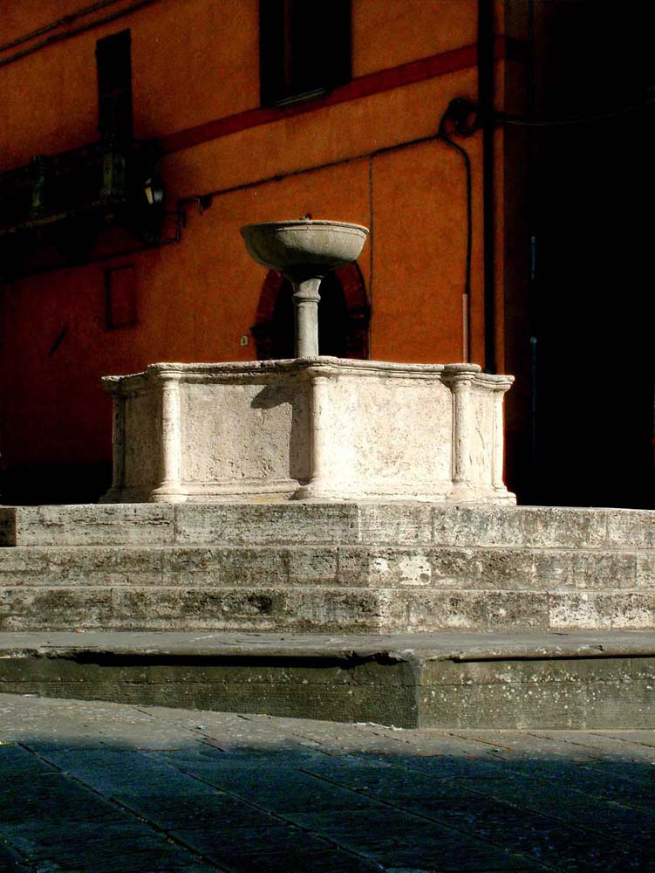

4 4

THE OLD CAMELLIA HOUSE

Here they once tended the camellias;
Now all the camellias are deceased,
Choked by the fresh flora that flourishes
In this broken purposed infirmary
For tender flowers consumed by the years.
The red, remembered as a period piece,
The white, no longer abed, still waiting
For the nurseryman’s nurturing hand.
Now never beheld through the shivered panes,
Les dames were offered no kindly mercy.
Today, the house is enclosed by nature
Before it too will return to the earth,
Reconciled with its red and white patients.

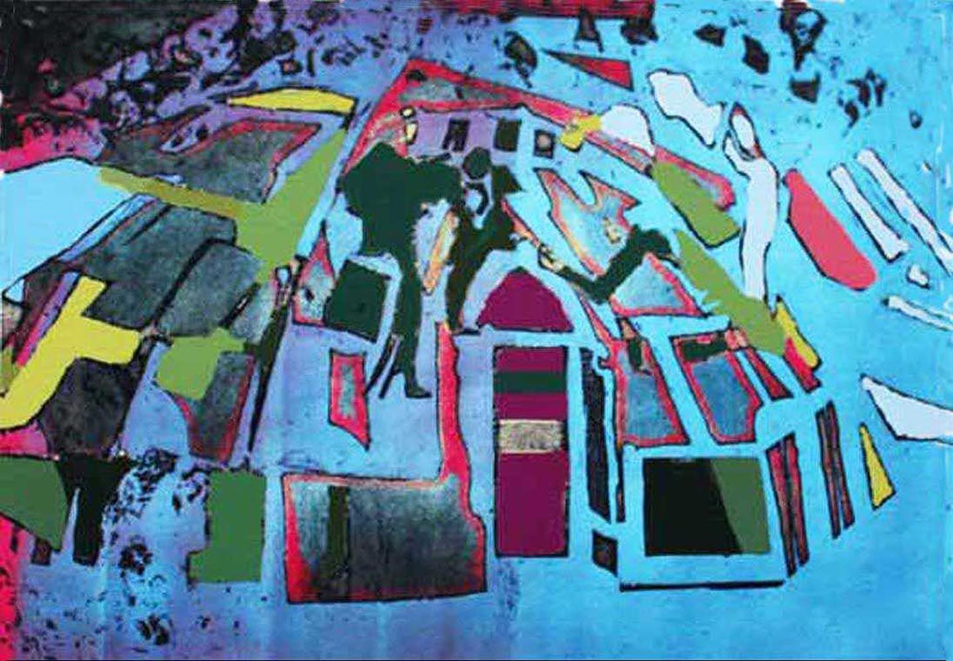

5

KNEELERS
AT BROAD CHALKE

You need to be supple for supplication
All that humble contorting of the knee.
Yet these comforting kneelers or hassocks -
They seem to be facing both ways at once:
The porch is both an entrance and exit;
The pig an ad, or off to the shambles?
Is the fox chasing prey or fleeing hounds?
The geese, Janus-like, looking left and right.
Only the tractor knows where it’s going -
It, and the loving sewer of kneelers.

But the mise-en-scene is painted blood red
And in the wings there is a dark shadow.

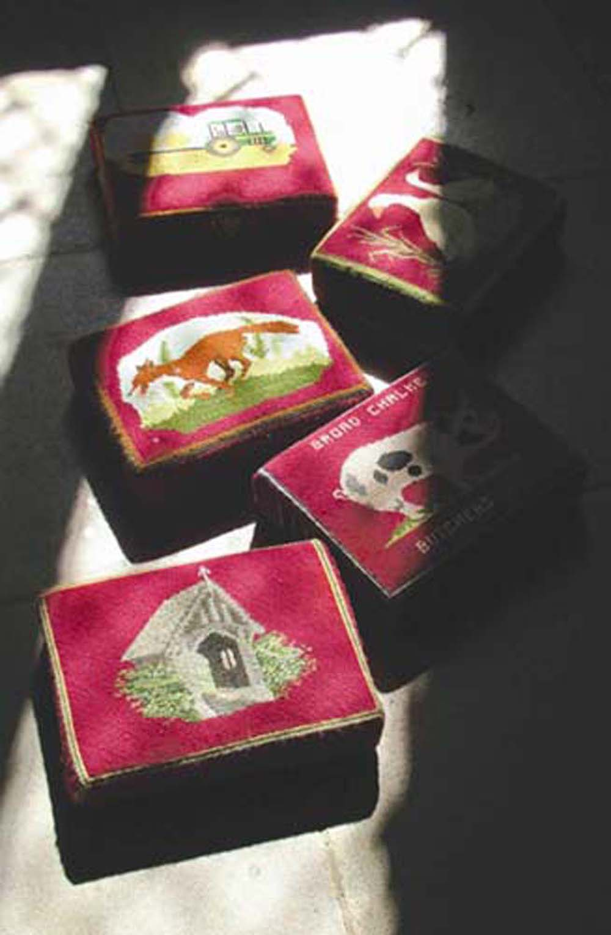

6
LA SACRESTIA ABBANDONATA

‘And what is actual is actual for only one time
And only one place…’

ASH WEDNESDAY T.S.Eliot

After saying the Latin Mass, the priest
Quietly closes the sacristy door.
It is Ash Wednesday and the sacristan –
The holy palm ash cross still on his brow –
Locks it fast shut until the next Sunday;
But forty days go by and no one comes
And the palm ashes are now holy dust.
Hidden in the wardrobe are the vestments:
The priest’s white alb tunic now not so pure;
His chasuble covering now sinned against;
His stole – at hand for drying – now unwashed.
Unconsecrated wines, some for the Mass,
Some wisely kept back for the thirsty priest,
Not needed now, and only vinegar.
The waiting jug is empty of water,
Of no use to the spirit of the stairs.
This place is no longer the only place,
Entombed now, not embalmed but decaying -
And what is actual is for all time.
After forty days it is deserted
And now forsaken for eternity.
The sacrestia abbandonata.

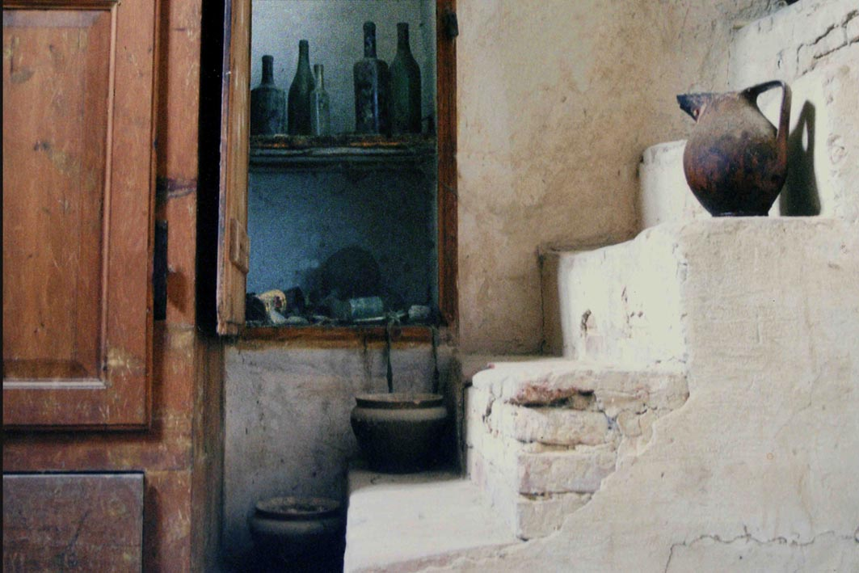

7

IL VICOLO

The Italians have theirs burnt or raw
In this Umbrian street or vicolo,
Coloured with the tints between earth and sky;
An empty alley of chiaroscuro;
A passage of Dante Alighieri,
Neither infernal nor ethereal.

Within ethereal are the letters
Available for spelling earth and heart
But neither the engulfed heart of darkness
Nor the effulgent light of the warm earth
Where doorways will emerge into sunlight,
To both a scorched world that turns the earth red
And a virgin landscape of uncooked greens.

An old vicolo with streaming flagstones
And mossy bricks and orange stuccoed walls
Built with the local pigments and baked earth,
Making in a tight space a universe,
A paved world of opposites united.

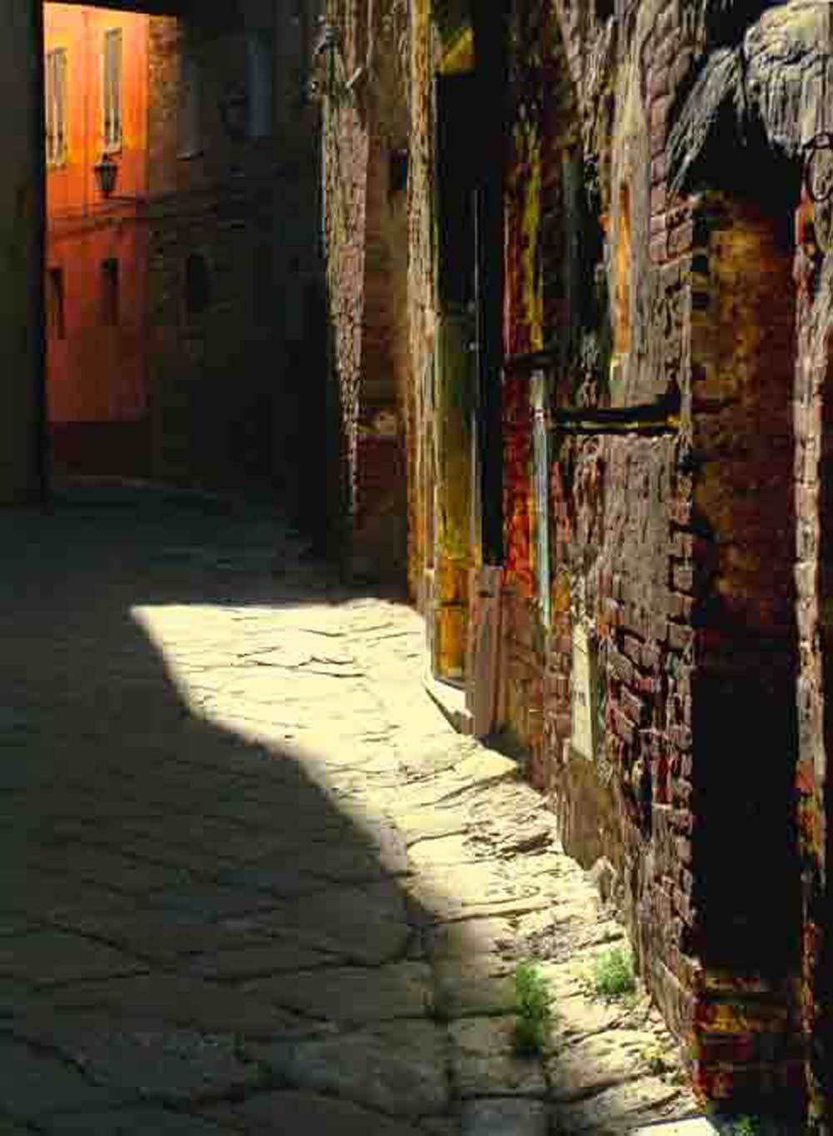

8
URBINO
Heading heavenwards, do they all assume
To be received by Raphael, the god-like
Son of Urbino, 'the little city’.
Are they stone upright Fathers of the Church
Who assume the Virgin's rise to heaven?
Standing erect is San Crescentinus,
A Roman soldier who slew a dragon,
Do they now assume a calm peacefulness?
Earthbound below is an upright figure;

She is striped white with no earthly shadow.
And a darkened pick-up truck with ladder.
Even on this terrestrial level,
In Our Lady’s holy sunlit churchyard,
The temporal words, pick-up and ladder
Must assume some form of levitation.

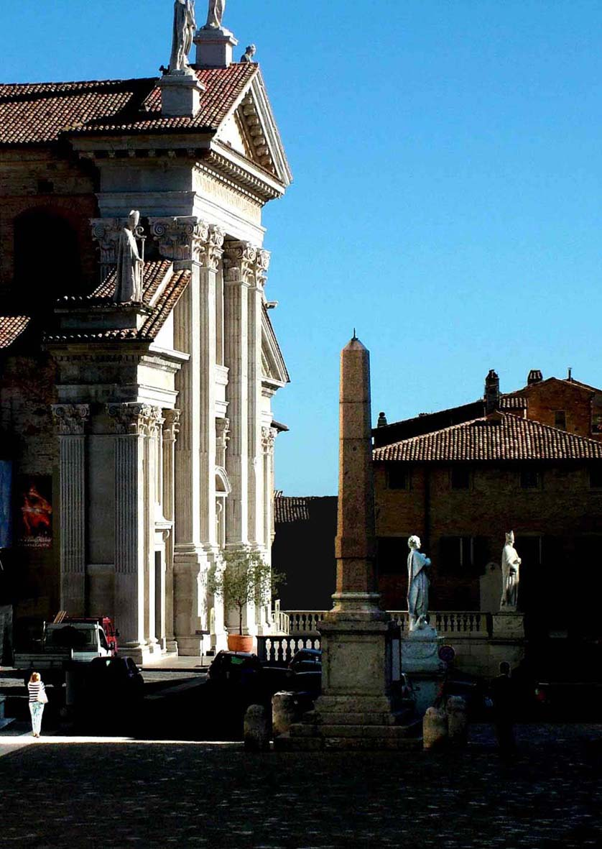

9

AGNUS DEI AT STEEPLE ASHTON

Somewhere the shepherd’s dedicated dog
Parted the lone lamb from his faithful flock
To make him an outcast in a fragment -
An exile in a black-bordered comic -
The rest of the back-lit story now lost
In the shivered glass - lost to the ages
Or rent by those fearful of an image.
So we will never know the last act.
The lamb looks back, not liking what he sees;
Not taking away the sins of the world
But fleeing, perhaps, from the ineffable,
Knowing he could never say, ‘Rest in peace’.

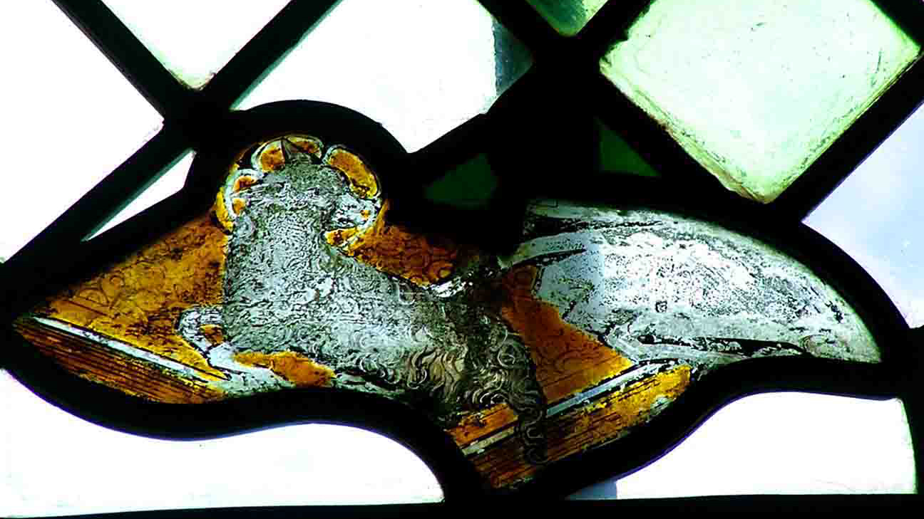

11
10

LA VESPA

There she is waiting, wearing the purple,
More royal than the absentee princess
Who went on an unscheduled holiday
In Rome tearing round the Colisseum.

(Although no relation, Vespasian’s
Monument to good fun and bloody game -
Torte e birra for the plebeians).

Attendant on her owner emerging,
Sensuously perched on radiant tiles,
Seemingly tethered to a Mondrian
Painted earth and ochre on an off day -
Wasp coloured walls sheltering violets.
Who will emerge in the cool, dark doorway?
For it can never be a Miss Hepburn
Or a Mr Peck, now crumbling like the walls;
But a ragazzo and aragazza,
Suitably alla m oda l'ultima,
As exhilarating as their fresh steed.

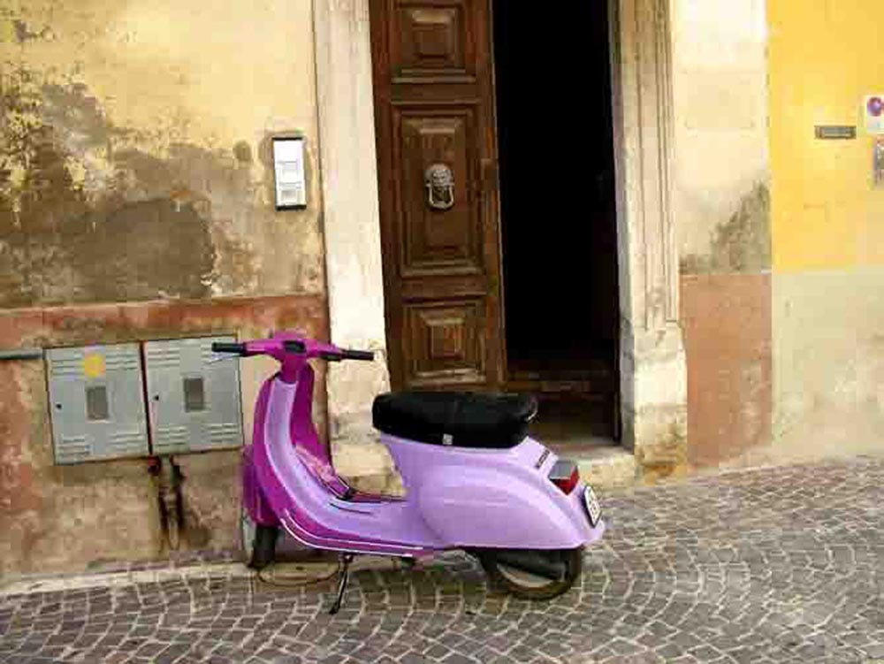

11

EX CATHEDRA or a MOVING PICTURE

Is this a snapshot of a searchlight?
Of a family of chairs in flight
Seeking refuge, escaping the chase
By the unseen pursuers off-screen?
Or a moving picture of a moon
Illuminating a darkened sky
That could be a haven or dead-end?
Or is it a clip of hanging chairs
Before falling to a fatal fate?
Or a still of six arrested seats
Awaiting their uncertain future?
Their shadows the images of bats,
That presage freedom from fearfulness.
Is the door an entrance or an exit
Into a land of hope or despair?
Is a chair without a seat, a chair?
Would Magritte say: “Ce n'est pas une chaise”.

In truth, they’re in a small Spanish church,
In brief suspended animation,
In stop-motion beneath an aisle roof.
Should they not be in a cathedral?
After all, is not a cathedral named
For the Chair which seats the archbishop?
For the Chair in which sits an archbishop?

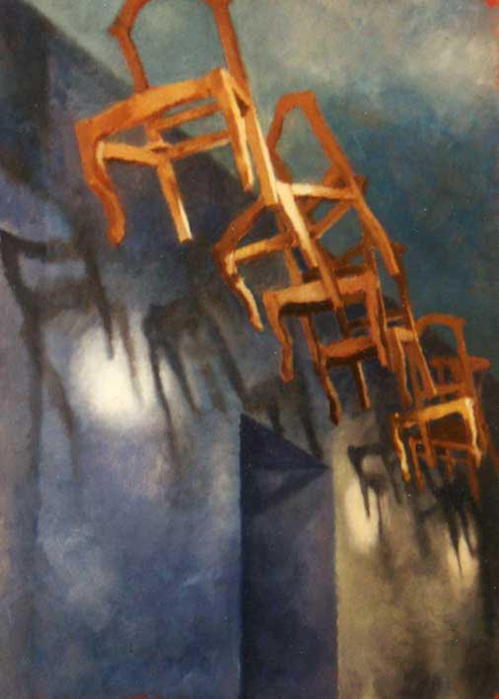

12

THE DIVINE PROPORTION

The earthly godlike proportion states:
The smaller part is to the greater
As the greater part is to the whole.
Did the gods on a Mount Arithmos
Come up with this divine division?
The alchemy of the Golden Mean.

A universal logarithmic
Is a phrase that counts, as all words do –
A phrase describing this mundane verse?
Is a logarithmic spiral’s song
A poem that could ascend or plunge?
A paradigm lost and then regained,
Scanning the gap between coupled words
Like heaven and hell or love and hate.
A precious proportion, though confined
In a golden rectangular page.

Or just say: 1 to point 618 –
That’s roughly one way of putting it.

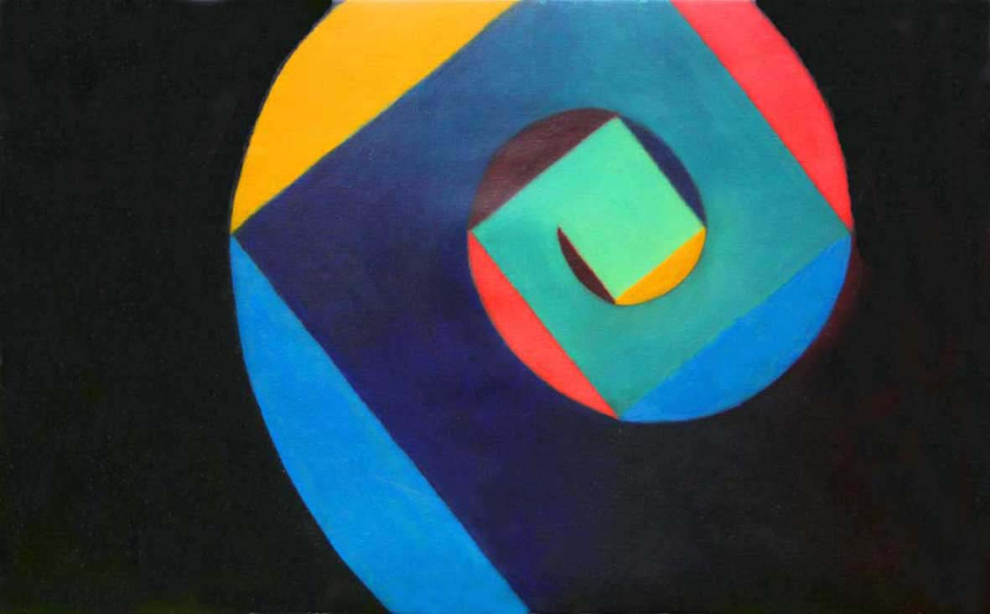

13

CHIAROSCURO

Clear and obscure means more than light and dark;
It’s more subtle than these stark opposites –
One cannot exist without its other.

I was once given some fragrant roses
Whose tenuous scent was also heady,
Whose quiet colours were yet effusive,
Whose caressing petals had a partner
Who crept up and cruelly drew my blood.

An entity can only be entire
When united with its vital allies,
Who, like antagonistic siblings,
Cannot abide each other’s company,
Till they understand that – to be as one –
Luminous male Yang needs alter ego
Yin, his tenebrous female counterpart.

Perhaps a painting is an entity
Which, when reconciled with adversaries,
Should combine with these erstwhile opponents
To create an undivided image -
Yet still a jigsaw of contradictions.

It should lie down to be seen in full sight,
And stand erect to be hidden away;
It should be imprecisely well-defined,
And unambiguously diffusive;
Sensuously curved and openly arced,
But within a linear straight-jacket;
With a perspective that’s a verity,
An illusion that hoodwinks nobody.

Contriving, either apart or as one,
To unmask the face of an artifice,
A breathing, inanimate entity,
Aspiring to an equilibrium.

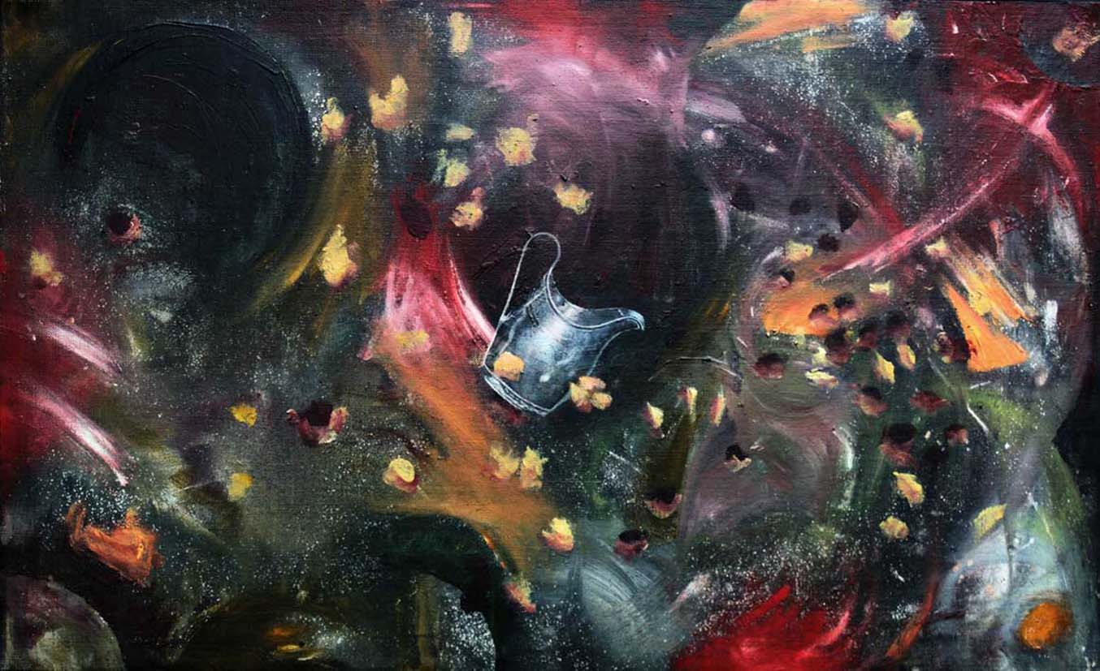

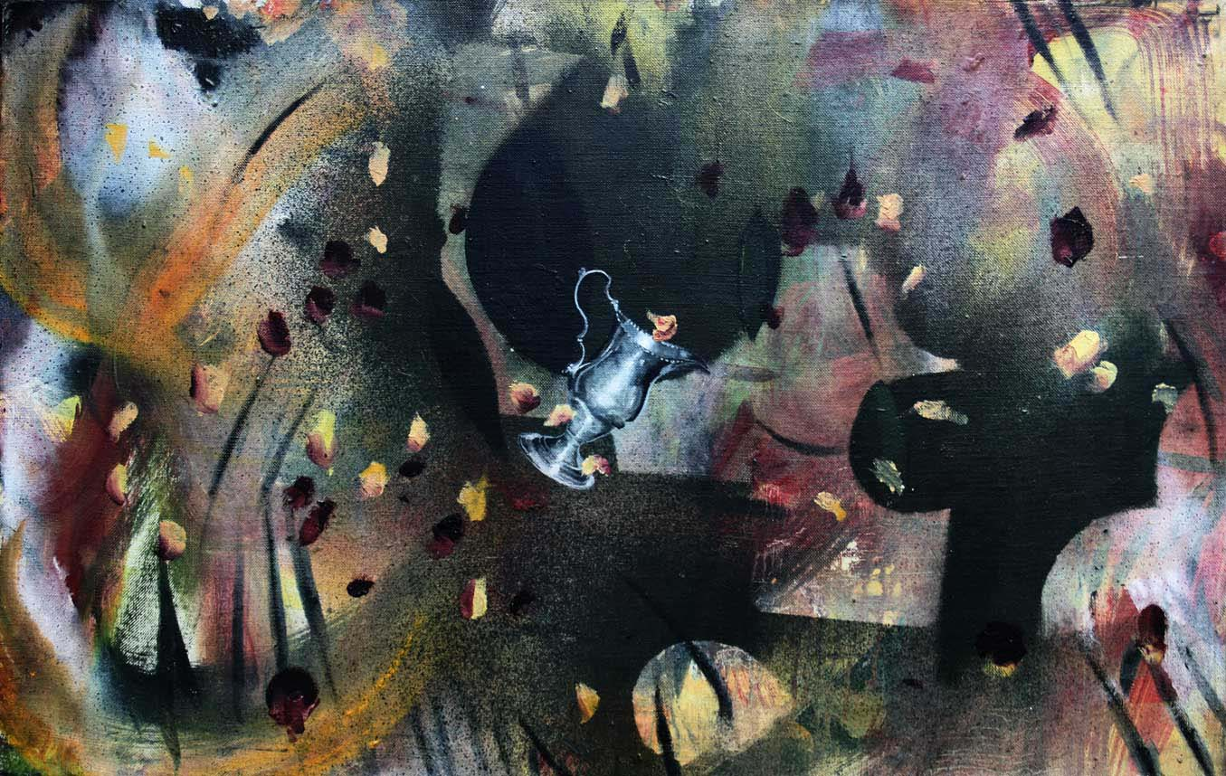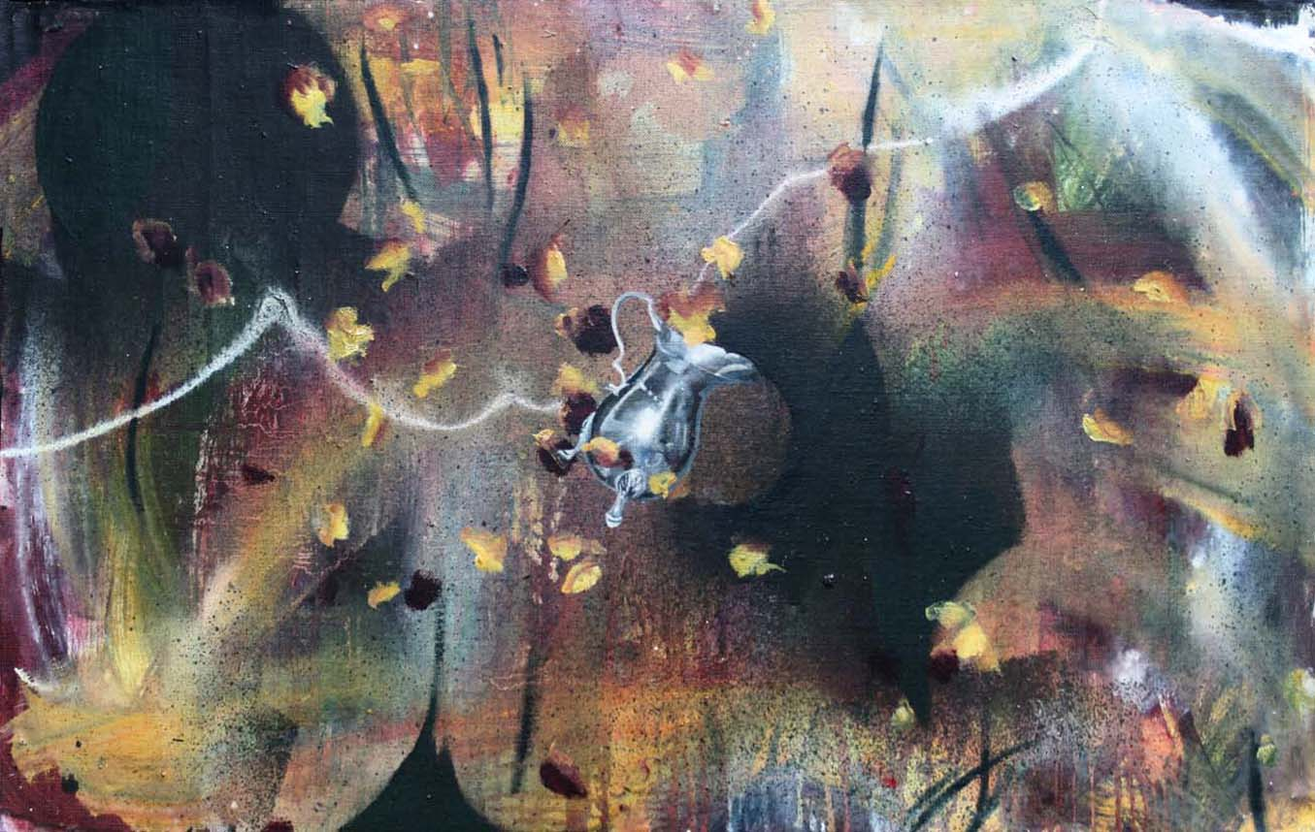

THE END

